**DAILY ONLINE ACTIVITIES SUMMARY**

|  |  |  |  |  |  |  |  |  |
| --- | --- | --- | --- | --- | --- | --- | --- | --- |
| **Date:** | **19/06/2020** | | | | | **Name:** | **Sannidhi P** | |
| **Sem & Sec** | **8th B** | | | | | **USN:** | **4AL16CS084** | |
| **Online Test Summary** | | | | | | | | |
| **Subject** | | **BDA** | | | | | | |
| **Max. Marks** | | **30** | | **Score** | | | **26** | |
| **Certification Course Summary** | | | | | | | | |
| **Course** | **SOLOLEARN** | | | | | | | |
| **Certificate Provider** | | | **JAVASCRIPT Tutorial** | | **Duration** | | | **2hr** |
| **Coding Challenges** | | | | | | | | |
| **Problem Statement:**  **Python program to print prime factors.** | | | | | | | | |
| **Status: Solved**  **Solution link: https://github.com/alvas-education-foundation/Sannidhi1** | | | | | | | | |
| **Uploaded the report in Github** | | | | | **Yes** | | | |
| **If yes Repository name** | | | | | **Sannidhi1** | | | |
| **Uploaded the report in slack** | | | | | **Yes** | | | |

Online test details:

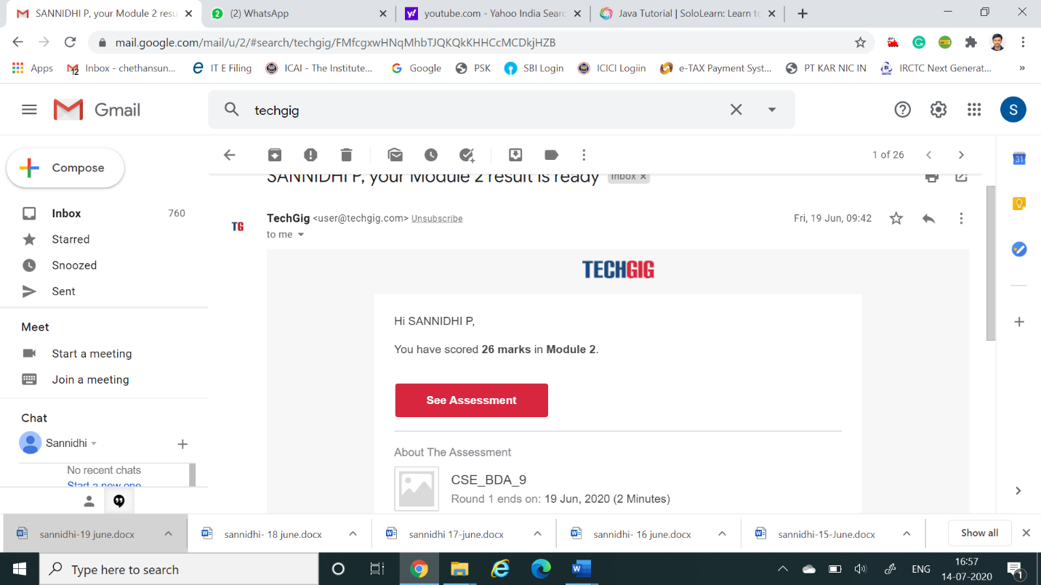

Certification Course Details:

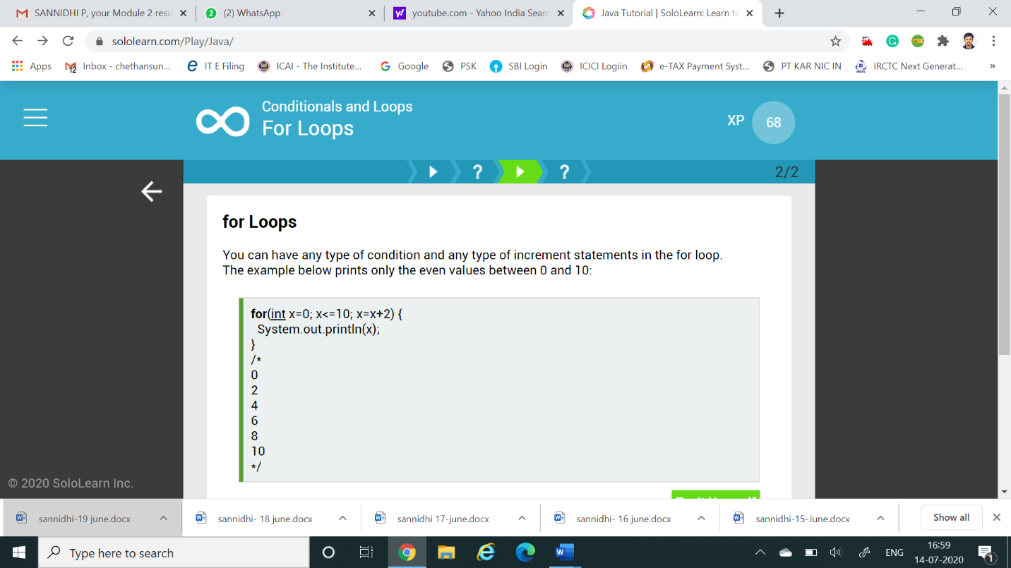

*Coding Challenges Details:*

import math

def primeFactors(n):

while n % 2 == 0:

print 2,

n = n / 2

for i in range(3,int(math.sqrt(n))+1,2):

while n % i== 0:

print i,

n = n / i

if n > 2:

print n

n = 315

primeFactors(n)